

UNIVERSITY OF BUEA
FACULTY OF ENGINEERING AND TECHNOLOGY
DEPARTMENT OF COMPUTER ENGINEERING
INTERNET PROGRAMMING AND MOBILE PROGRAMMING
CEF440
Task 6: Database design and Implementation

GROUP 9
NAME | MATRICULE
FONTEBO TCHICKNWIGHE ACHAH | FE23A062
ANU ROLENCE AKEM | FE23A013
NEIL AMBAYI MPOCHE | FE23A105
OTANG JANICE OTANG | FE23A134
ASHU ALBERIC BESSONG | FE23A015

1. Introduction
This report covers the database design and implementation phase of the BrainPath Adaptive E-Learning Platform. The database forms the backbone of the system, storing all information related to users, courses, learning content, progress tracking, assessments, and adaptive recommendations. A well-structured database ensures data consistency, integrity, and efficient retrieval across all platform features.
The report covers the work done on the following components for the development of the system:
- Data Elements – identifying all data entities and attributes
- Conceptual Design – high-level data modelling
- ER Diagram – Entity-Relationship diagram
- Database Implementation – creating the physical database
- Backend Implementation – server-side logic connecting to the database
- Connecting the Database to the Backend – integration and testing

2. Data Elements
Before designing the database, all data elements needed by the BrainPath platform were identified and categorised. The following entities and their key attributes were determined based on the system requirements gathered in earlier tasks.

2.1 Core Entities

2.1.1 Users
Stores information about all registered users (students, instructors, administrators).
Attribute | Data Type | Constraint | Description
user_id | INT | PRIMARY KEY | Unique user identifier
username | VARCHAR(50) | UNIQUE, NOT NULL | Login username
Email | VARCHAR(100) | UNIQUE, NOT NULL | User email address
password_hash | VARCHAR(255) | NOT NULL | Encrypted password
Role | ENUM | NOT NULL | student / instructor / admin
full_name | VARCHAR(100) | NOT NULL | Full name of user
created_at | DATETIME | DEFAULT NOW() | Account creation timestamp
profile_picture | VARCHAR(255) | NULLABLE | URL to profile image

2.1.2 Courses
Stores information about all available learning courses on the platform.
Attribute | Data Type | Constraint | Description
course_id | INT | PRIMARY KEY | Unique course identifier
Title | VARCHAR(150) | NOT NULL | Course title
description | TEXT | NULLABLE | Full course description
instructor_id | INT | FOREIGN KEY | References Users(user_id)
category | VARCHAR(80) | NOT NULL | Subject category
difficulty | ENUM | NOT NULL | beginner / intermediate / advanced
created_at | DATETIME | DEFAULT NOW() | Course creation timestamp
is_published | BOOLEAN | DEFAULT FALSE | Publication status

2.1.3 Lessons
Attribute | Data Type | Constraint | Description
lesson_id | INT | PRIMARY KEY | Unique lesson identifier
course_id | INT | FOREIGN KEY | References Courses(course_id)
Title | VARCHAR(150) | NOT NULL | Lesson title
content_type | ENUM | NOT NULL | video / text / quiz / interactive
content_url | VARCHAR(255) | NULLABLE | Link to lesson content/media
order_index | INT | NOT NULL | Lesson ordering within course
duration_min | INT | NULLABLE | Estimated duration in minutes

2.1.4 Enrollments
Attribute | Data Type | Constraint | Description
enrollment_id | INT | PRIMARY KEY | Unique enrollment record
student_id | INT | FOREIGN KEY | References Users(user_id)
course_id | INT | FOREIGN KEY | References Courses(course_id)
enrolled_at | DATETIME | DEFAULT NOW() | Enrollment timestamp
completion_status | ENUM | DEFAULT 'active' | active / completed / dropped
progress_pct | DECIMAL(5,2) | DEFAULT 0.00 | Overall course progress (%)

2.1.5 Assessments & Quiz Results
Attribute | Data Type | Constraint | Description
result_id | INT | PRIMARY KEY | Unique result identifier
student_id | INT | FOREIGN KEY | References Users(user_id)
lesson_id | INT | FOREIGN KEY | References Lessons(lesson_id)
Score | DECIMAL(5,2) | NOT NULL | Score achieved (out of 100)
attempt_no | INT | DEFAULT 1 | Number of attempts made
submitted_at | DATETIME | DEFAULT NOW() | Submission timestamp

2.1.6 Adaptive Recommendations
Attribute | Data Type | Constraint | Description
rec_id | INT | PRIMARY KEY | Unique recommendation ID
student_id | INT | FOREIGN KEY | References Users(user_id)
recommended_lesson_id | INT | FOREIGN KEY | References Lessons(lesson_id)
Reason | TEXT | NULLABLE | Algorithm reasoning text
generated_at | DATETIME | DEFAULT NOW() | When recommendation was made

3. Conceptual Design
The conceptual design provides a high-level, implementation-independent view of the data model for Brainpath. It focuses on what data needs to be stored and how the main entities relate to each other, without specifying database-specific details such as data types or primary keys.

3.1 Key Entities and Relationships
The following describes the main relationships between entities:
- A User can be a Student, Instructor, or Administrator (generalisation/specialisation).
- An Instructor creates and manages one or more Courses.
- A Student enrolls in one or more Courses through an Enrollment record.
- Each Course contains one or more Lessons.
- Lessons can be of different types: Video, Text, Quiz, or Interactive Content.
- A Student completes Lessons and their results are stored as Quiz Results / Assessment Records.
- The platform's adaptive engine generates Recommendations for students based on their performance data.

3.2 Conceptual Diagram
The conceptual model is illustrated below. This is a simplified entity map showing main entities and the nature of their relationships before any formal ER notation is applied.
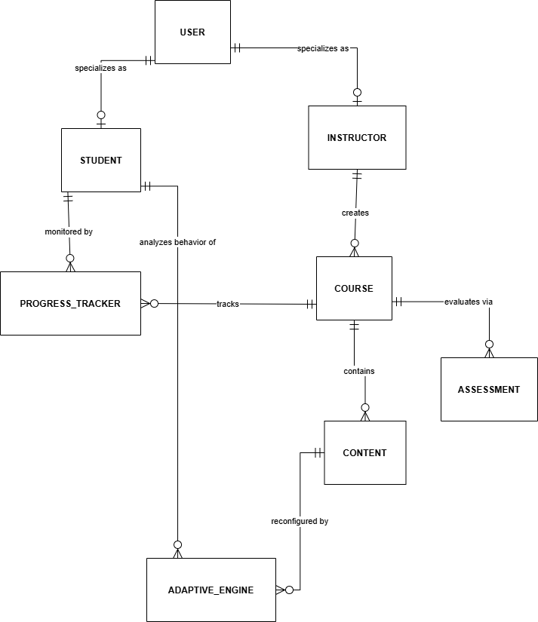
Figure 1: View of the High Level conceptual diagram

4. ER Diagram (Entity-Relationship Diagram)
The Entity-Relationship (ER) Diagram provides a formal graphical representation of the database schema, showing all entities, their attributes, primary/foreign keys, and the cardinalities of relationships.

4.1 Relationships Summary

Relationship | Cardinality | Description
Users Students | 1 to (0...1) | One user account can have at most one student profile.
Users Instructors | 1 to (0...1) | One user account can have at most one instructor profile.
InstructorsCourses | 1 to Many | One instructor creates many courses.
Students Courses | Many to Many | Many students can enroll in many courses via the progress tracker table.
Courses Content | 1 to Many | One course has many content items (videos, files, documents)
Courses Assessments | 1 to Many | One course has many assessments and quizzes.
Students Progress Trackers | 1 to Many | One student has many progress tracker logs (one for each course).
Courses Progress Trackers | 1 to Many | One course tracks progress for many students.
Students Adaptive Engines | 1 to Many | One student generates many behavioral recommendation requests.
Content Adaptive Engines | 1 to Many | One content item can be rearranged or modified by many engine rules.

4.2 ER Diagram
The ER Diagram below was designed using draw.io and shows all entities with their attributes and relationships with proper crow's-foot notation.

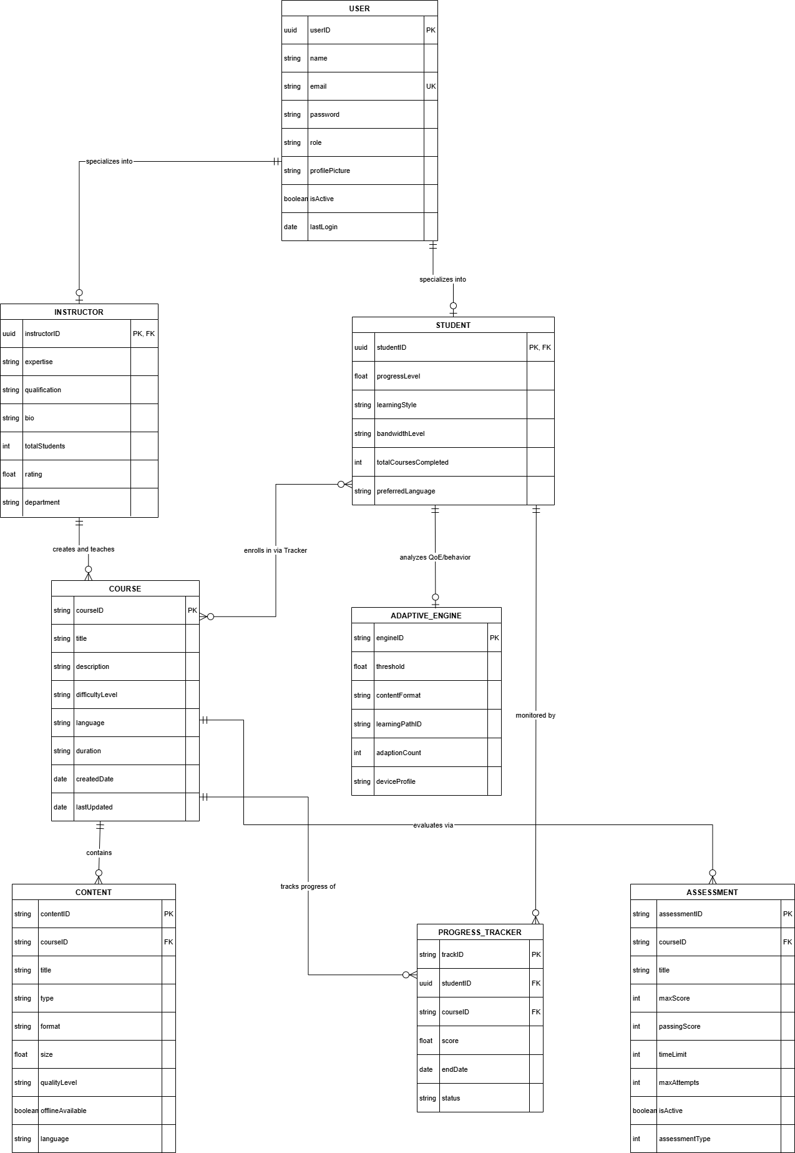
Figure 2: View of the System ER-Diagram.

5. Database Implementation
This section covers the creation of the physical database using MySQL/PostgreSQL/SQLite. The database was implemented based on the ER diagram designed in Section 4.

5.1 Database Setup
The following steps were carried out to set up the database:
- Installed and configured the database management system (MySQL Workbench / phpMyAdmin / PostgreSQL).
- Created a new database schema named brainpath_db.
- Executed the SQL DDL scripts to create all tables.
- Inserted sample seed data for testing purposes.

5.2 SQL DDL Script – Table Creation
The SQL script below was used to create all tables in the database:
-- Users Table
CREATE TABLE Users (
user_id INT AUTO_INCREMENT PRIMARY KEY,
username VARCHAR(50) UNIQUE NOT NULL,
email VARCHAR(100) UNIQUE NOT NULL,
password_hash VARCHAR(255) NOT NULL,
role ENUM('student','instructor','admin') NOT NULL,
full_name VARCHAR(100) NOT NULL,
created_at DATETIME DEFAULT NOW(),
profile_picture VARCHAR(255)
);
-- Courses Table
CREATE TABLE Courses (
course_id INT AUTO_INCREMENT PRIMARY KEY,
title VARCHAR(150) NOT NULL,
description TEXT,
instructor_id INT NOT NULL,
category VARCHAR(80) NOT NULL,
difficulty ENUM('beginner','intermediate','advanced') NOT NULL,
created_at DATETIME DEFAULT NOW(),
is_published BOOLEAN DEFAULT FALSE,
FOREIGN KEY (instructor_id) REFERENCES Users(user_id)
);
-- Enrollments, Lessons, Quiz_Results, Recommendations
-- (Full SQL script attached in Appendix)

5.3 Database Implementation Screenshots
Tables Created – Database schema view
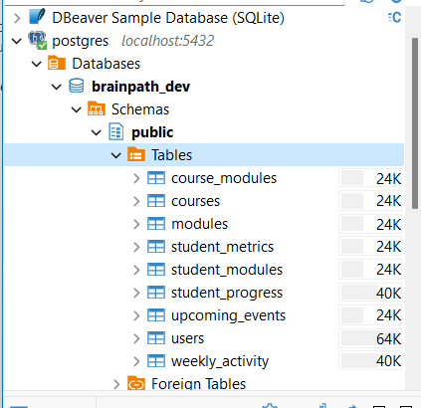
Figure 3: View Showing tables Created – Database schema view
Populated tables
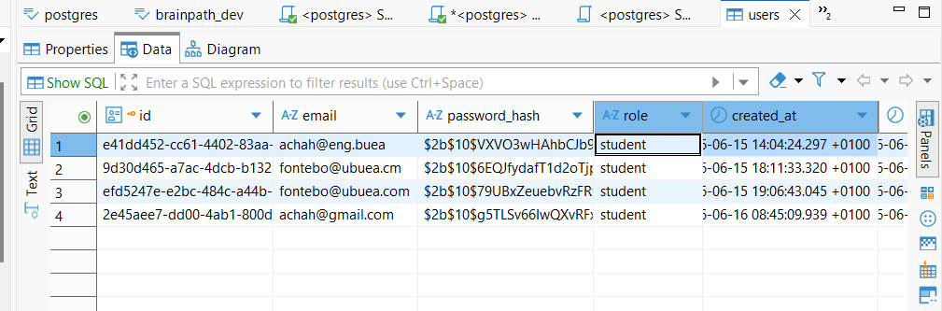
Figure 4: User table Populated with sample data

6. Backend Implementation
The backend of Brainpath was implemented as a RESTful API using Node.js with Express.js. The backend handles all business logic, processes client requests, queries the database, and returns JSON responses.

6.1 Technology Stack
Component Component | Technology Used
Backend Framework | Node.js + Express.js (or Python Flask)
Database | PostgreSQL
ORM / DB Driver | pg
Authentication | JWT (JSON Web Tokens) + bcrypt
API Standard | REST (JSON over HTTP)
Environment Config | .env file with dotenv package

6.2 Backend Project Structure
brainpath-backend/
├── config/
│ └── db.js # Database connection
├── models/
│ ├── User.js # User model
│ ├── Course.js # Course model
│ └── Enrollment.js # Enrollment model
├── routes/
│ ├── auth.js # Login/register routes
│ ├── courses.js # Course CRUD routes
│ └── users.js # User management routes
├── middleware/
│ └── auth.js # JWT middleware
├── .env # Environment variables
└── server.js # Main entry point

6.3 Key API Endpoints

Method | Endpoint | Auth Required | Description
POST | /api/auth/register | No | Register a new user
POST | /api/auth/login | No | Login and receive JWT token
GET | /api/courses | No | Retrieve all published courses
POST | /api/courses | Yes (Instructor) | Create a new course
GET | /api/courses/:id | No | Get a single course by ID
POST | /api/enroll | Yes (Student) | Enroll student in a course
GET | /api/progress/:id | Yes (Student) | Get student progress

6.4 Backend Implementation Screenshots
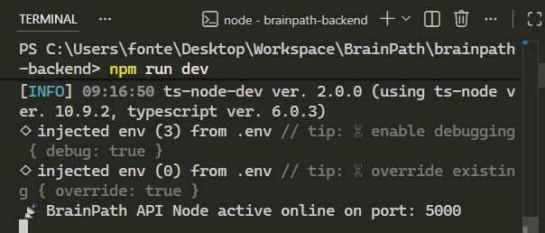
Figure 5: Backend Server Running

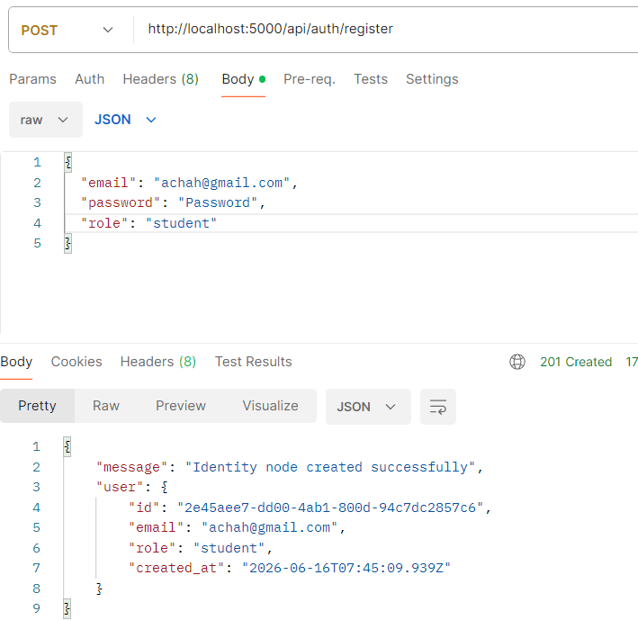
Figure 6: API Registration Endpoint Testing – Postman.

7. Connecting the Database to the Backend
This section documents how the backend application was connected to the PostgreSQL database and how data flows between the two layers.

7.1 Database Connection Configuration
The database connection is managed in the config/db.js file using environment variables stored in a .env file for security:
// .env file
DB_HOST=localhost
DB_USER=root
DB_PASS=your_password
DB_NAME=brainpath_db
PORT=5000
JWT_SECRET=your_jwt_secret_key
// config/db.js
const mysql = require('mysql2');
const pool = mysql.createPool({
host: process.env.DB_HOST,
user: process.env.DB_USER,
password: process.env.DB_PASS,
database: process.env.DB_NAME
});
module.exports = pool.promise();

7.2 Data Flow
The following describes how a typical request flows from the frontend through the backend to the database:
- 1. The frontend (React) sends an HTTP request to a backend API endpoint.
- 2. Express.js routes the request to the appropriate controller/handler function.
- 3. The middleware checks for a valid JWT token (for protected routes).
- 4. The controller executes an SQL query against the MySQL database via the connection pool.
- 5. The database returns the result to the controller.
- 6. The controller formats the response as JSON and sends it back to the frontend.

7.3 Integration Testing
Integration testing was performed to confirm that all API endpoints correctly read from and write to the database. The following tests were conducted:
- User registration: confirmed that a new record appears in the Users table after POST /api/auth/register.
- Course creation: confirmed new course row in Courses table after POST /api/courses.
- Enrollment: confirmed new record in Enrolments table after POST /api/enrol.
- Progress retrieval: confirmed GET /api/progress/:id returns accurate data from the database.

7.4 Connection and Integration Screenshots
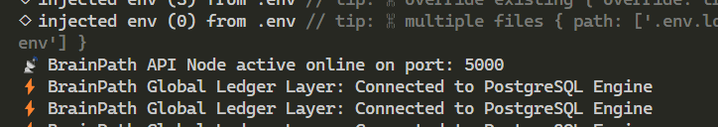
Figure: Successful Database Connection Log

Figure 7: View of Successful request sent to database.
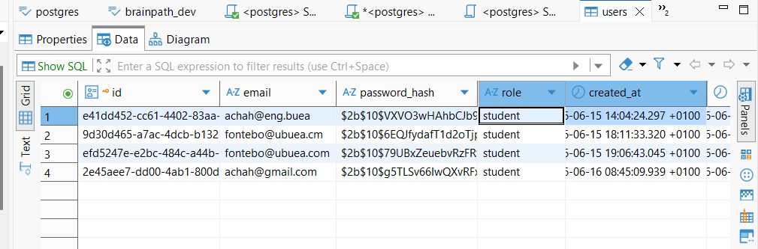
Figure 8: View of changes made to Database table due to data entered.

8. Conclusion
This report has documented the complete database design and implementation process for the Brainpath Adaptive E-Learning Platform as required by Task 6. Beginning with a systematic identification of all data elements, a conceptual model was developed and formalised into a full Entity-Relationship diagram. The physical database was subsequently implemented using SQL, and a RESTful backend was developed to serve as the interface between the frontend and the database.
All major components data elements, conceptual design, ER diagram, database implementation, backend implementation, and full integration have been successfully completed and tested. The system is now capable of storing and retrieving all user, course, lesson, enrollment, assessment, and recommendation data required by the platform.

